A000-Asia-Gandhara Buddha, Kushan Period, ca. 3rd century CE.

Case no.: 3

Gandhara Buddha, Kushan Period, ca. 3rd century CE, schist. H: 7 3/4" x BASE 5.5" x actual figurine 5"high.

This Buddha from Ghandara is carved from schist. When Alexander the Great conquered Gandhara in 330 BCE with Indo-Greek kings, he introduced Greek artistic traditions deriving from Apollo Belvedere (330 BCE) and are found in both the drapery of this Buddha’s himation or robe and his stylized wavy topknot or ushnisha. He is seated on a pedestal rather than a lotus leaf before a circular aureola and underneath a Greek-style freize. This rare example of Graeco-Buddhist art demonstrates syncretism between eastern and western traditions.

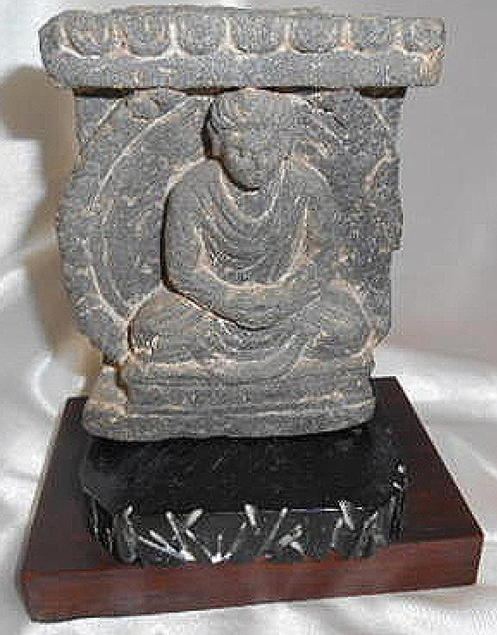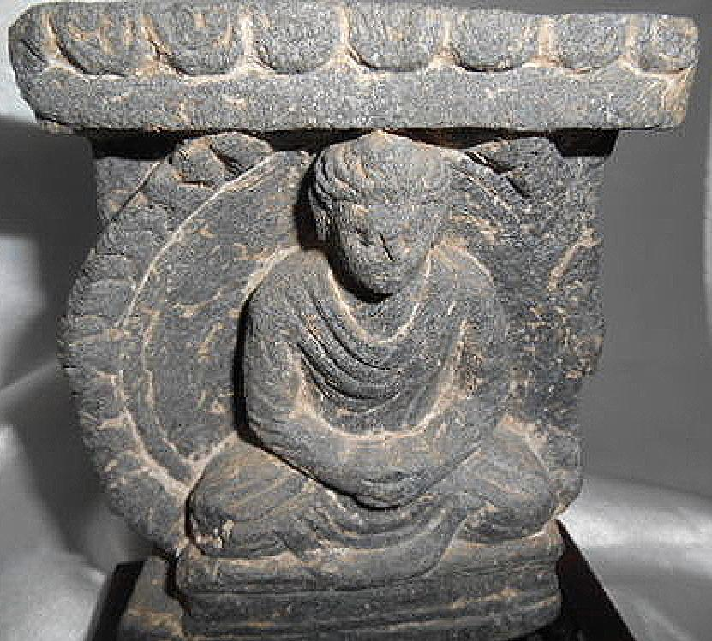

Sold by [proverbs22_1](http://myworld.ebay.com/proverbs22_1) ( [1871](http://feedback.ebay.com/ws/eBayISAPI.dll?ViewFeedback&userid=proverbs22_1) )

+ Show additional actions

### Delivery package 1 of 1

Estimated delivery Wednesday, May 25, 2016 -Saturday, May 28, 2016

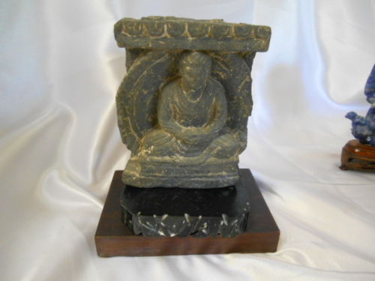

#### [Gandhara/Gandharan Stone Figure 300 AD Western Pakistan](http://www.ebay.com/itm/301846177299)

|  |  |
| --- | --- |
| **Item price** | $285.00 |
| **Quantity** | 1 |
| **Item number** | 301846177299 |
| **Shipping service** | USPS Priority Mail |

[Contact seller](http://contact.ebay.com/ws/eBayISAPI.dll?FindAnswers&frm=3998&iid=301846177299&redirect=0&requested=proverbs22_1)

[Return item](https://www.ebay.com/rtn/Return/ReturnViewSelectedItem?transactionId=1260731703020&itemId=301846177299&_trksid=p2057872.m2749.l3185)

## Shipping address

Ralph J Coffman Jr

149 Atlantic Ave

Swampscott MA 01907-2427

United States

## Order total

|  |  |
| --- | --- |
| **Subtotal** | $285.00 |
| **Shipping** | $31.82 |

**Total**

$316.82

[View PayPal transaction](http://payments.ebay.com/ws/eBayISAPI.dll?UnifiedCheckoutSummaryRedirect2PP&itemid=301846177299&transId=1260731703020&buyerorseller=0)

Order placed on

Monday, May 23, 2016

Payment method

PayPal

Payment date

Monday, May 23, 2016